**WITH NOISE AND WITH FILTER**

**Image set:**

|  |
| --- |
| **Image 1:-0.1 % Noise** |

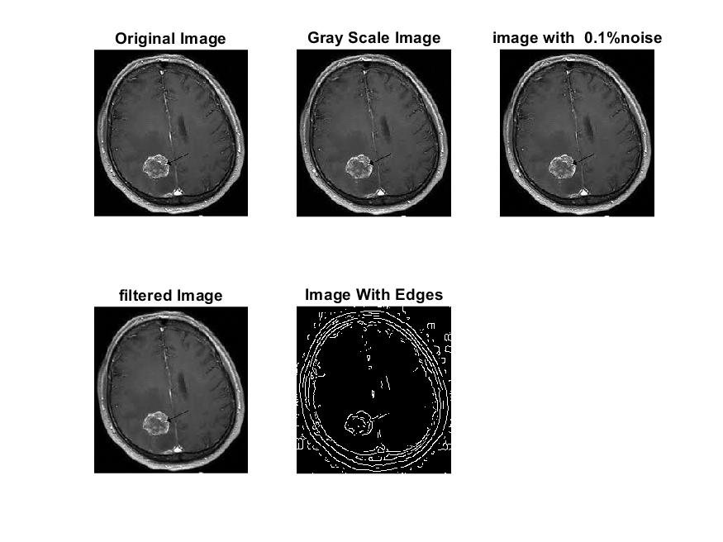

**Image 2:-10 % Noise**

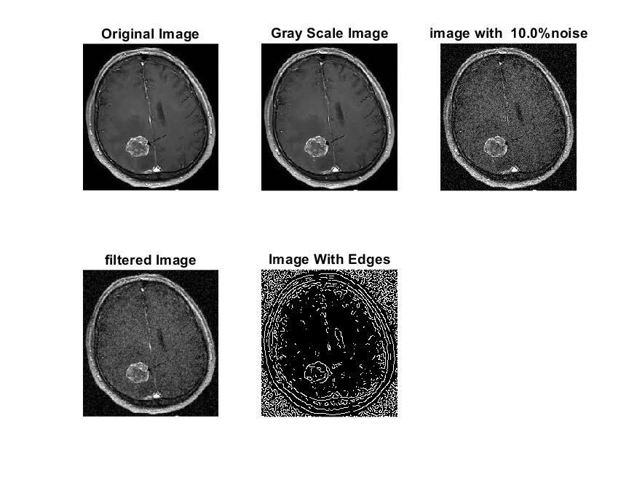

**Image 3:-20 % Noise**

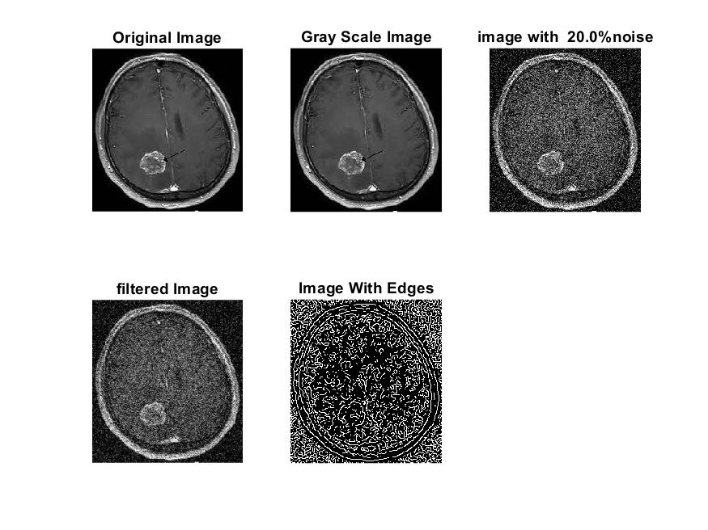

**Image 4:-30 % Noise**

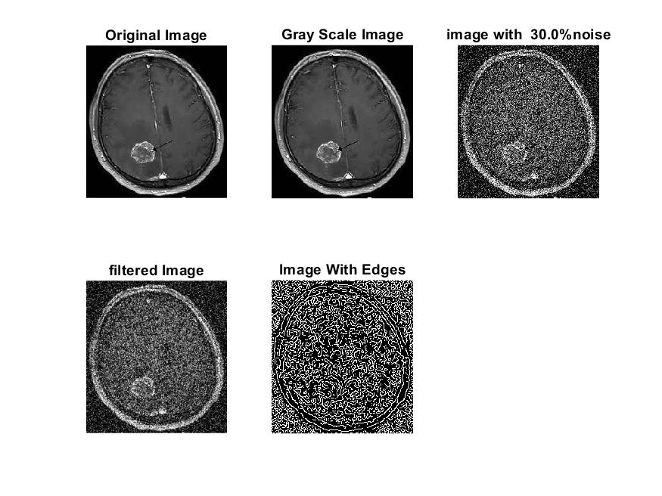

|  |
| --- |
| **Image 5:-40 % Noise** |

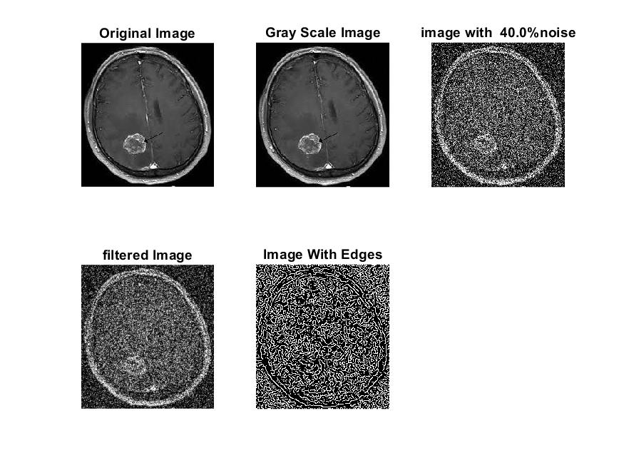

**Image 6:-50 % Noise**

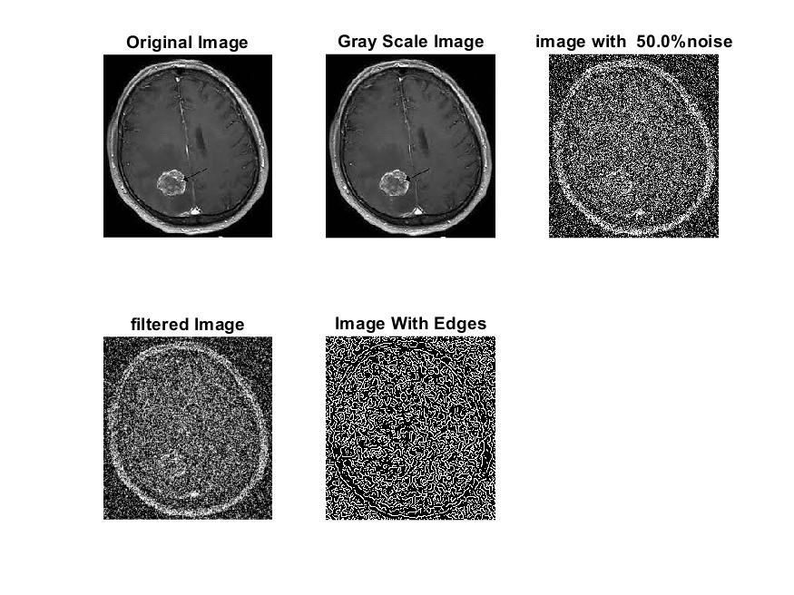

**Image 7:-60 % Noise**

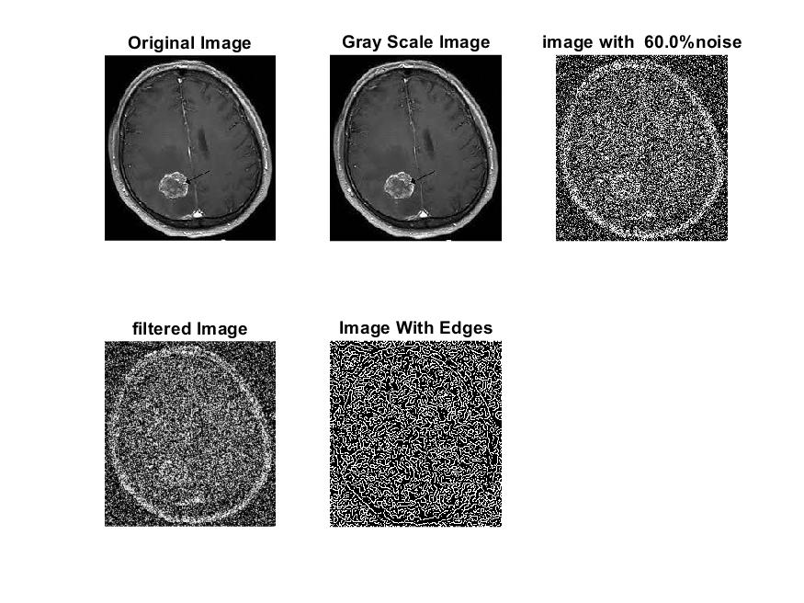

**Image 8:-70 % Noise**

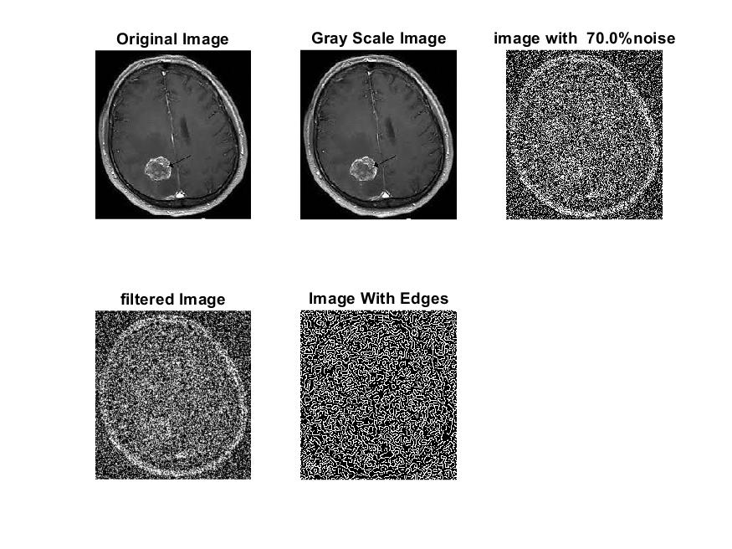

**Image 9:-80 % Noise**

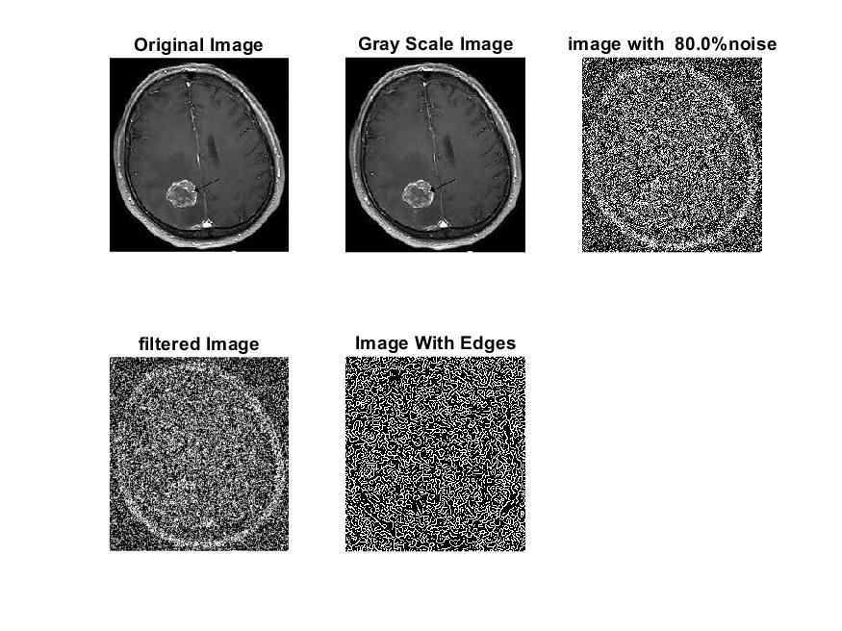

**DATA FILES**

**Image 1:-Noise0.1**

Original image ideal values:

IM1 image entropy:4.134745e-01

IM1 image mean:0.083234

Ground truth image entropy:0.746959

Ground truth image mean:0.212884

entropy between imt and im1 :0.686999

MSE between imt and im1 :0.236724

Average Difference between imt and im1 :0.129649

Maximum Difference between imt and im1 :1.000000

True Positive values:1501.000000

False Positive values: 2706.000000

True Negative values:37078.000000

False Negative values:9259.000000

Accuracy value: 0.763276

F Measure values:0.200575

Peak Signal-to Noise Ration value: 6.257569

Signal-to Noise Ration value: -4.078398

percentage of pixels that were correctly detected (Pco): 0.139498

The percentage of pixels that were not detected (Pnd):0.860502

the percentage of false alarm: (Pfa):0.251487

Euclidean Distance Value :13.017709

**Image 2:-Noise10**

Original image ideal values:

IM1 image entropy:6.490568e-01

IM1 image mean:0.166251

Ground truth image entropy:0.746959

Ground truth image mean:0.212884

entropy between imt and im1 :0.674465

MSE between imt and im1 :0.308266

Average Difference between imt and im1 :0.046633

Maximum Difference between imt and im1 :1.000000

True Positive values:1791.000000

False Positive values: 6612.000000

True Negative values:33172.000000

False Negative values:8969.000000

Accuracy value: 0.691734

F Measure values:0.186923

Peak Signal-to Noise Ration value: 5.110743

Signal-to Noise Ration value: -1.073779

percentage of pixels that were correctly detected (Pco): 0.166450

The percentage of pixels that were not detected (Pnd):0.833550

the percentage of false alarm: (Pfa):0.614498

Euclidean Distance Value :15.709777

**Image 3:-Noise20**

Original image ideal values:

IM1 image entropy:7.857208e-01

IM1 image mean:0.234469

Ground truth image entropy:0.746959

Ground truth image mean:0.212884

entropy between imt and im1 :0.651215

MSE between imt and im1 :0.355947

Average Difference between imt and im1 :-0.021585

Maximum Difference between imt and im1 :1.000000

True Positive values:2310.000000

False Positive values: 9541.000000

True Negative values:30243.000000

False Negative values:8450.000000

Accuracy value: 0.644053

F Measure values:0.204325

Peak Signal-to Noise Ration value: 4.486143

Signal-to Noise Ration value: 0.419427

percentage of pixels that were correctly detected (Pco): 0.194920

The percentage of pixels that were not detected (Pnd):0.713020

the percentage of false alarm: (Pfa):0.805080

Euclidean Distance Value :18.548409

**Image 4:-Noise30**

Original image ideal values:

IM1 image entropy:8.596138e-01

IM1 image mean:0.283080

Ground truth image entropy:0.746959

Ground truth image mean:0.212884

entropy between imt and im1 :0.632078

MSE between imt and im1 :0.388335

Average Difference between imt and im1 :-0.070196

Maximum Difference between imt and im1 :1.000000

True Positive values:2720.000000

False Positive values: 11588.000000

True Negative values:28196.000000

False Negative values:8040.000000

Accuracy value: 0.611665

F Measure values:0.217010

Peak Signal-to Noise Ration value: 4.107936

Signal-to Noise Ration value: 1.237667

percentage of pixels that were correctly detected (Pco): 0.190103

The percentage of pixels that were not detected (Pnd):0.561923

the percentage of false alarm: (Pfa):0.809897

Euclidean Distance Value :18.061811

**Image 5:-Noise40**

Original image ideal values:

IM1 image entropy:8.846695e-01

IM1 image mean:0.302786

Ground truth image entropy:0.746959

Ground truth image mean:0.212884

entropy between imt and im1 :0.623213

MSE between imt and im1 :0.400720

Average Difference between imt and im1 :-0.089902

Maximum Difference between imt and im1 :1.000000

True Positive values:2905.000000

False Positive values: 12399.000000

True Negative values:27385.000000

False Negative values:7855.000000

Accuracy value: 0.599280

F Measure values:0.222913

Peak Signal-to Noise Ration value: 3.971588

Signal-to Noise Ration value: 1.529927

percentage of pixels that were correctly detected (Pco): 0.189820

The percentage of pixels that were not detected (Pnd):0.513265

the percentage of false alarm: (Pfa):0.810180

Euclidean Distance Value :18.031666

**Image 6:-Noise50**

Original image ideal values:

IM1 image entropy:9.018010e-01

IM1 image mean:0.317644

Ground truth image entropy:0.746959

Ground truth image mean:0.212884

entropy between imt and im1 :0.609167

MSE between imt and im1 :0.404222

Average Difference between imt and im1 :-0.104760

Maximum Difference between imt and im1 :1.000000

True Positive values:3192.000000

False Positive values: 12863.000000

True Negative values:26921.000000

False Negative values:7568.000000

Accuracy value: 0.595778

F Measure values:0.238076

Peak Signal-to Noise Ration value: 3.933800

Signal-to Noise Ration value: 1.737980

percentage of pixels that were correctly detected (Pco): 0.198817

The percentage of pixels that were not detected (Pnd):0.471380

the percentage of false alarm: (Pfa):0.801183

Euclidean Distance Value :18.927145

**Image 7:-Noise60**

Original image ideal values:

IM1 image entropy:9.060074e-01

IM1 image mean:0.321502

Ground truth image entropy:0.746959

Ground truth image mean:0.212884

entropy between imt and im1 :0.602935

MSE between imt and im1 :0.403134

Average Difference between imt and im1 :-0.108618

Maximum Difference between imt and im1 :1.000000

True Positive values:3317.000000

False Positive values: 12933.000000

True Negative values:26851.000000

False Negative values:7443.000000

Accuracy value: 0.596866

F Measure values:0.245613

Peak Signal-to Noise Ration value: 3.945507

Signal-to Noise Ration value: 1.790411

percentage of pixels that were correctly detected (Pco): 0.204123

The percentage of pixels that were not detected (Pnd):0.458031

the percentage of false alarm: (Pfa):0.795877

Euclidean Distance Value :19.455887

**Image 8:-Noise70**

Original image ideal values:

IM1 image entropy:9.107594e-01

IM1 image mean:0.325973

Ground truth image entropy:0.746959

Ground truth image mean:0.212884

entropy between imt and im1 :0.606633

MSE between imt and im1 :0.410533

Average Difference between imt and im1 :-0.113090

Maximum Difference between imt and im1 :1.000000

True Positive values:3243.000000

False Positive values: 13233.000000

True Negative values:26551.000000

False Negative values:7517.000000

Accuracy value: 0.589467

F Measure values:0.238141

Peak Signal-to Noise Ration value: 3.866515

Signal-to Noise Ration value: 1.850395

percentage of pixels that were correctly detected (Pco): 0.196832

The percentage of pixels that were not detected (Pnd):0.456239

the percentage of false alarm: (Pfa):0.803168

Euclidean Distance Value :18.728736

**Image 9:-Noise80**

Original image ideal values:

IM1 image entropy:9.166049e-01

IM1 image mean:0.331652

Ground truth image entropy:0.746959

Ground truth image mean:0.212884

entropy between imt and im1 :0.594500

MSE between imt and im1 :0.406675

Average Difference between imt and im1 :-0.118768

Maximum Difference between imt and im1 :1.000000

True Positive values:3484.000000

False Positive values: 13279.000000

True Negative values:26505.000000

False Negative values:7276.000000

Accuracy value: 0.593325

F Measure values:0.253170

Peak Signal-to Noise Ration value: 3.907521

Signal-to Noise Ration value: 1.925395

percentage of pixels that were correctly detected (Pco): 0.207839

The percentage of pixels that were not detected (Pnd):0.434051

the percentage of false alarm: (Pfa):0.792161

Euclidean Distance Value :19.824569